Conestoga College

Disassembling a PC

And what the parts do

Matthew Cunningham

W24-A+ Essentials-Hardware

Professor James Stewart

February 28th, 2023

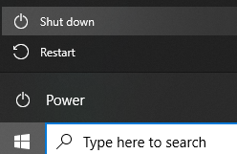**Step 1 - Unplugging**

When disassembling a computer, the very first step is to shut down the computer.This can be down in two ways, either by pressing the windows start button (or whatever the equivalent is on other OS, such as mac), or by pressing the physical top power switch.

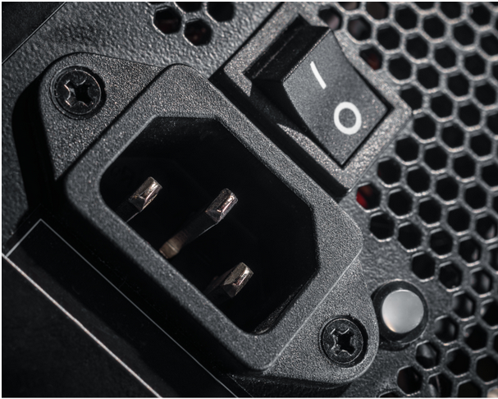Then, if applicable, the power supply switch which can typically be found on the back of the PC, must be switched off as well to ensure that the PC is completely off. At this point, we can now safely unplug the PC from the wall outlet. It is important to ensure that the PC is properly powered off before turning off the PSU or unplugging it, as not doing this can cause data loss, OS issues, or even damage to hardware components.

After ensuring that it has safely been turned off and disconnected from power, there may still be some leftover residual energy in the PC, so it is recommended to wait around 5-10min to allow the charge to dissipate before continuing to the next step. At this point I am going to place my PC on an anti-static mat in a clean space and use and put on an anti-static wrist strap that is connected to the mat, and go onto the next step.

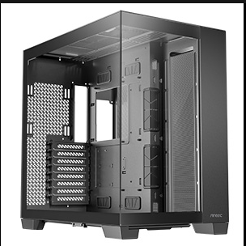**Step 2 - The Casing**

The next step of disassembling a computer is to remove some of the case parts to allow access to the internal hardware. But first, what is the casing and why do we need it? Well, the case is the entire housing of the entire system. It holds all of the hardware into a single, clean and organized spot, while also protecting all of the components.

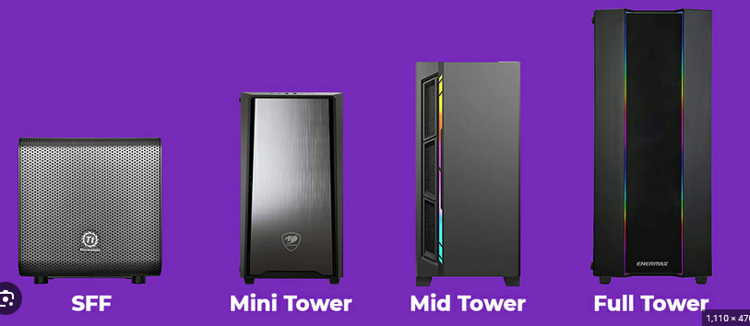It is often designed with specific needs in mind, and has places in it made to hold every part required to build the PC, and then some. The case of the PC will often determine exactly what kind of PC you are able to build. Personally, when building a new PC, one of the first considerations I take is deciding on the case as then I can decide what level of parts I can fit. With there being many different sizes of cases you need to make sure that you select one that will fit your use case. Want to build a gaming PC that will require a massive GPU? I would go for a full tower E-ATX so I have sufficient space for the current hardware as well as for future hardware that I may want to upgrade. Looking to build a small server? You can likely get away with a SFF/ Mini-ITX case. There are 4 major case sizes, but these also have some variants. I am personally in the process of setting up a Plex Media Server and will be purchasing a SFF PC as it will be able to fit exactly what I need while not taking up too much space.

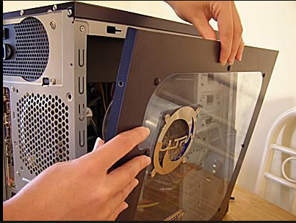Now, what needs to be done to your case when disassembling a PC? The first step would be to remove the side paneling . This may be held on by screws, or it may not. My personal PC has a swing open side panel, which is visually appealing, but was actually quite annoying when building the PC as it got in the way a lot. Depending on your case, the side panel may be the only major part you need to remove. Some cases can also have their front or top panels removed (if they have them), but often I find you don’t need to remove these to get to the good stuff. Depending on the PC you are dissembling, there will be different brackets and such that you will also need to be removed, such as the GPU bracket mount or a mount for the PSU, but again this is all dependent on the system you are disassembling. I will go more into the removal of these specific parts as we go through the disassembly steps.

**Step 3 - The Power Supply**

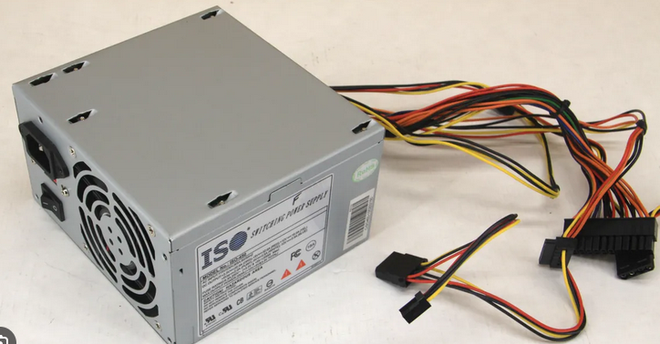Once we have removed any case parts that will get in the way, we can now move onto the power supply. We have already turned its power switch off, unplugged it from the outlet, and allowed it to discharge. But what does the PSU actually do for the computer? Well, as it is aptly named, it provides power to the entire PC. Without this component, nothing will work, for obvious reasons. It provides power to the hardware either through the motherboard (which then provides the power to connected devices) or also by directly connecting to other components, such as the GPU, storage devices, and even case fans. It is important when building a PC to ensure you select a PSU that can provide enough power to all of the components. People will often “future proof” by buying a PSU that has way more power than needed, in the hopes that when upgrading other components in the future, they can retain the same PSU and still have enough power for the new components. The PSU is also, in my opinion, one of the easier components to troubleshoot, as if your PC is simply not receiving any power (motherboard light isn’t even turning is a good indicator), then it’s likely a loose connection somewhere with your PSU or your PSU has died. This is easy to replace.

At this stage of disassembly, we will now remove the bracket that is holding the PSU, and unplug any connections to other components. It will need to be unplugged from the motherboard and any other components its connected to (again, possibly the GPU, storage drives, case fans, etc.)

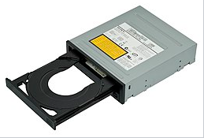**Step 4 - CD/DVD Drive**

We will now work on the optical drive of the PC. The optical CD/DVD drive is a less common component of modern PCs, but in the past it was seen as a massive advancement compared to the floppy drives that came before it. It offered a huge increase in storage space, writing speeds, and allowed the user to consume different content such as music, videos, or even install software. It also offered better portability as the CDs and DVDs were easier to carry around and store than its predecessors.

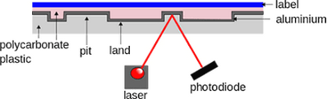The optical drive utilizes lasers and diodes to detect differences in the reflection from the laser. The CDs/ DVDs themselves contain microscopic “pits” on them that represent binary data for which the computer can then read using the optical drive. The drive can also write data to the disks using the same laser to create the pits as mentioned before.

Over the years, the optical drive has had many advancements and iterations, with each version often providing even more storage space and capabilities. The first 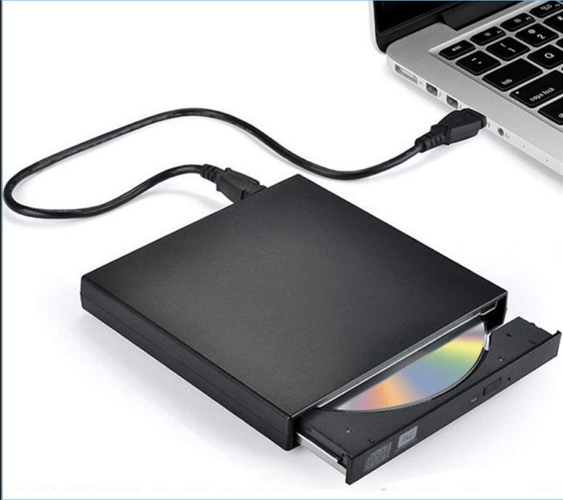optical drive (CD-ROM) could read data only and not write data, and held very little space. Today, our optical drives are capable of reading and writing to disks with massive storage space and with very high quality. They have gotten smaller as well and there are even optical drives that can be bought and connected externally, simply through USB.

We will now remove the optical drive from the PC by first removing its bracket and disconnecting it. It is often connected to the motherboard via a SATA data cable and to the PSU via a SATA power cable. We can disconnect these cables from the motherboard or PSU and free the optical drive from its enclosure.

**Step 5 - System Fans**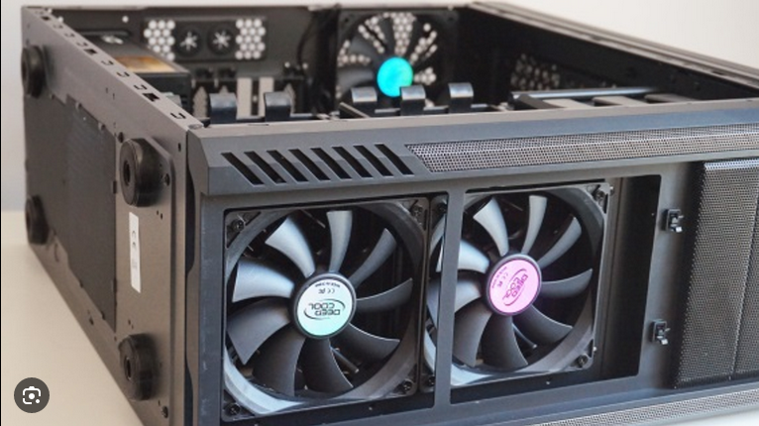

It is now time to take the case fans out. In any computer system, it is vital to have sufficient cooling. While there are newer, less common cooling methods around these days (water cooling for example), cooling fans (case fans) still reign supreme as the choice for the majority of PC owners. These come in many forms and are used for multiple components, such as the CPU fan, or the PSU and GPU which often have built in fans, but for this step I will only go into the system fans which are typically installed around the different sides of the case. 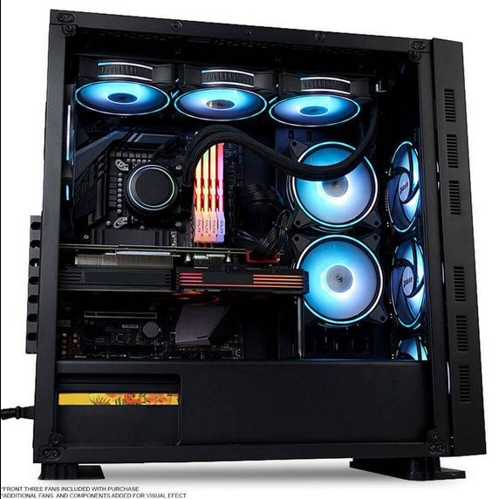

These fans can come in different sizes, speeds, and can have better or worse cooling capabilities at different price ranges. They can even be controlled (speed, curve, RGB color) through software when connected to the motherboard. When installed correctly, they work by pushing air throughout the case and over the components to help dissipate heat, and then push that hot air out of the case through various vents. Modern PC cases often have an excess of fan slots, with different configurations having fans that can be on the top, front, back, bottom, or even on the panel (on the cable management side). My personal gaming PC has 3 fans on the front, 3 on the top, and 2 on the bottom, with even 2 more slots being open.

Most commonly, these fans are connected directly to the motherboard via dedicated fan headers. They can also sometimes be connected to the PSU with molex connectors, but this isn’t very common these days as there would be no support for configuring them with software. So, for this step we will disconnect all of the case fans from the headers on the motherboard and set them aside.

**Step 6 - CPU Fans**

Moving on to the next step, let’s talk about the CPU fan. Arguably the most important fan that any setup will need, the CPU fan will often come packaged with a motherboard or CPU and will usually include a heatsink. It is absolutely vital for the lifespan and proper operating of your CPU that you ensure this is set up correctly, as an overheating unit can be a huge issue. In addition to the fan and heatsink, a proper application of thermal paste should be applied to the chip directly for optimal performance and longevity. The heatsink is designed very specifically to allow heat from the surrounding area (the CPU) to dissipate more effectively through it. Then, the fan attached to the heatsink pushes air through the heatsink’s fins which helps to get rid of the heat more effectively. We will talk more in depth about the heatsink and how it works later in this lab. 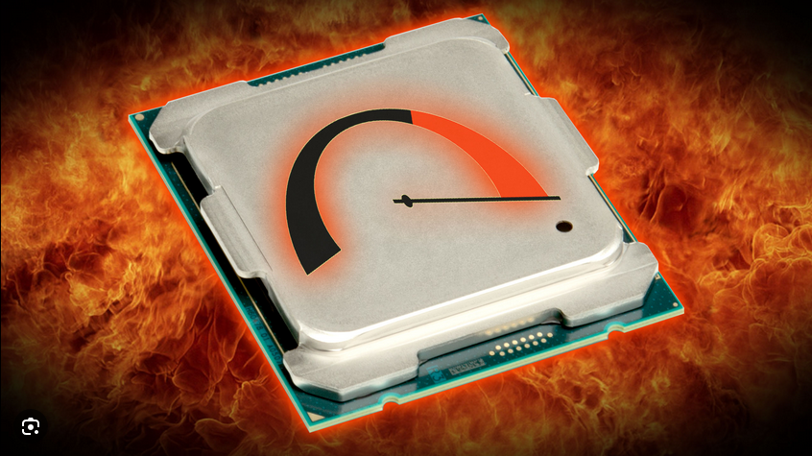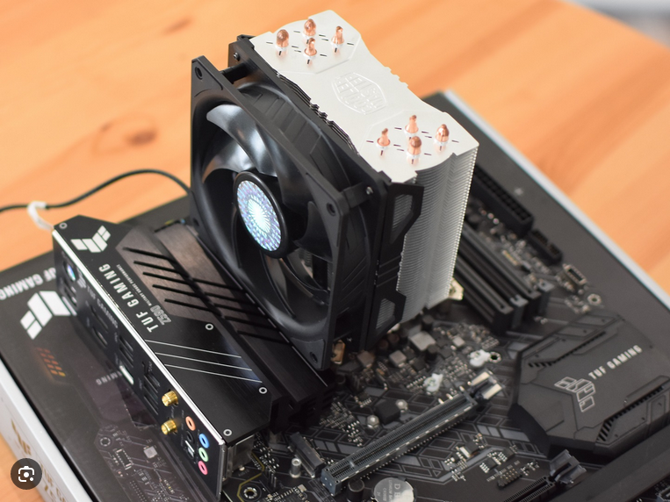

As with most PC components, the more you spend on the CPU fan, the better performance you will have. While on some other parts you can sacrifice some quality by spending a little bit less money, I think it is important that you shell out a little bit extra to get a high quality CPU fan and heatsink. This is because these components are essentially what prevent any CPU chip from failure or running into problems. Even if your chip doesn’t overheat to the point of breaking, an overheating CPU will heavily reduce your PC’s performance, especially in gaming rigs. So ensuring that your CPU fan + heatsink is more than capable of sufficiently cooling your CPU is a must in my opinion. The stock fan + heatsink combos that often come packaged with motherboards/ CPUs can sometimes be enough but often aren’t great.

In modern systems, the fan will most likely be attached directly to the heatsink. In older systems, maybe not. Sometimes there wasn’t even a fan and only “passive” heatsink. In the case that it isn’t attached to the heatsink, we can simply remove it from its bracket (if any) and unplug it either from its header pin on the motherboard, or from the PSU, depending where it is plugged in. If the fan does happen to be attached to the, we will go ahead and remove both the fan and heatsink. The heatsink is likely screwed into threads in the motherboard so we will need to undo those. Once the fan (or both the fan and heatsink) have been removed, we can put them to the side. We will now have access to the CPU to look at later in this lab.

**Step 7 - Hard Drive / Floppy or additional Disk Drive**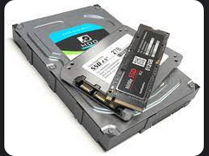

Now that we have successfully removed the various fans from the case, let’s go ahead and discuss the various storage devices we might see on a computer. There are many options ranging from tiny to large, cheap to expensive, slow to fast and everything else in between. Most commonly in today’s age, we will see HDD (Hard Drive Disks), SATA SSDs (Solid State Drives via SATA connection), or m.2 SSDs (Solid State Drives via m.2 connection). Hard drives are typically the slowest, largest and most cumbersome option, however they yield the best storage to price ratio. They also have moving parts and are more prone to breaking if dropped, or even just breaking over time from the parts wearing out. SATA SSDs on the other hand, are much faster and sleeker, are less likely to break because they have no moving parts, and are smaller. Yet, people will still often take the disadvantages of an HDD because a SATA SSD of the same storage capacity is often double the price of a comparable HDD. You can also purchase both of these in external formats in case you have run out of room in the case. We then have the more recent development of the m.2 SSD. It has been gaining a lot of popularity because, compared to a SATA SSD, it is even smaller (very small, to be specific) and for most people easier to install. It also boasts even faster than its sibling because it can utilize either the PCIe or NVMe interfaces which have much faster data transfer rates than SATA. My own gaming PC has an m.2 drive which is where I have all of my games installed as it allows for much much faster loading times and other benefits. Most motherboard manufacturers today are now including support for m.2 SSDs in their boards, however, it is important to note that there are two types of m.2s, one with a “b” key shape which only supports SATA and one with an “m” key which is the one that supports PCIe or NVMe. So when selecting a motherboard we ideally want it to be compatible with an m key m.2

Those are the most common drive types we see today, but there are others. For those who can’t decide between a SATA SSD or an HDD, they have the option of getting the best of both worlds in “Hybrid Drives”, also known as SSHDs. These drives combine the use of solid state memory and spinning disks to provide both fast speeds and high storage capacities, with a similar price point to a normal HDD. Another that we rarely see any more, but are still out there in computers which we today would probably consider to be ancient, are floppy disks, which require a floppy drive to use. They had little storage space (given, at the time our files didn’t take up that much space anyway), were very fragile and slow, and could only be written to so many times before they died. It’s amazing how we have come from that, to what we have now. An interesting fact about floppy disks is that the “save” icon that most of the world knows and still uses to this day, is based on the floppy disk!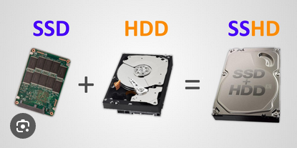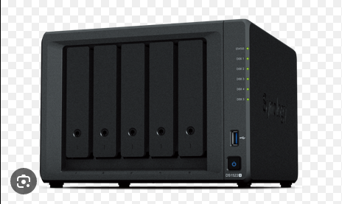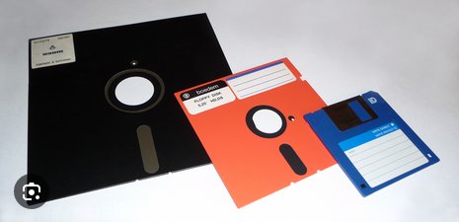

This isn’t exactly a disk drive, but I want to talk about it anyway! One more type of storage we can discuss is what is called “Network Attached Storage”, or NAS for short. NAS devices are essentially just a storage chassis holding multiple storage devices, typically using a RAID configuration, that can have multiple different uses. It can act as a data backup, file sharing system with multiple users being able to pull from and contribute to the data, or even some sort of server. A NAS can hold as little as 2 storage devices (Most commonly SATA SSD or HDD), or as many devices as you can fit in the chassis. Many companies will use these devices in huge configurations and it is even common among tech enthusiasts who want to archive data or set up some kind of file server. I myself want to build a NAS one day to store my movie collection and serve it to Plex.

So, removing any of these storage devices will be wildly different from one another. It completely depends on which one(s) are installed on our PC. For a SATA SSD or HDD, we will need to disconnect the SATA cable from the motherboard and then any power cables leading to the PSU (which we did earlier in the 2nd step when we removed the PSU from the PC). For an m.2 SSD, we simply need to unscrew the screw that attaches it to the motherboard, and remove it from its slot. A floppy drive we would likely need to unscrew from the case and disconnect the ribbon cable that was standard for these. And for a NAS, since it is external and is essentially its own system, we wouldn’t need to do anything!

**Step 8 - The Power Switch** 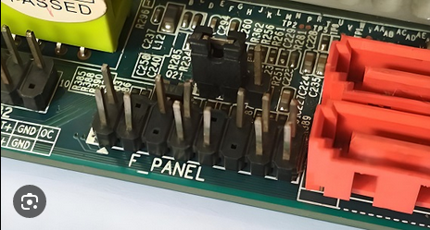

The power switch on a PC isn’t a super complicated part. It is aptly named and does exactly what it says, which is to switch the power on and off. To explain how the power switch works, first we must know that the motherboard on the PC has a specific group of pins that are usually referred to as the “front panel header”. This header is also aptly named as it too describes exactly what it is for, which is to connect any of your typical front panel components to the motherboard, such as the restart button, power ON/OFF indicator light, USB ports, audio jack, etc. 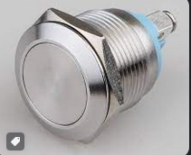

Now, onto the power switch itself. As mentioned, it is connected to the front panel header on the motherboard. This type of switch is specifically called a :”momentary switch”, which just means that it simply returns to its original position after being released from a press. This allows for the state of the button to be able to facilitate both power off and power on functions without wildly changing its position (whereas something like a light switch completely moves directions and stays like that until you flip it the other way). This type of switch also helps to prevent accidentally powering off your system, as the top of the switch is usually level with the top of the case so you are unlikely to press it by mistake as opposed to something like a lever switch.

When your PC is off, and you press the switch, the first thing that will happen is the BIOS/ UEFI will begin a POST (Power On Self Test). This process checks the components of your PC to ensure everything will run smoothly and work. If there are issues, this is where you might run into a booting error, such as the blue screen “Something Went Wrong :(“ on windows. If there are no issues, BIOS/ UEFI will then initiate the bootloader code and initialize the operating system on your specified drive. This will land you on the user sign-in screen unless you disabled the need to login. 

When your PC is on and you press the switch, your motherboard will signal to your operating system that it is time to shut down. The OS will tell the user, ask if they are sure, prompt them to save any open unsaved files, and then initiate the rest of its shutdown protocols. Once finished it then calls back to the motherboard to tell it to power down the system, and the motherboard then tells the PSU to cut the power.

The power switch is simply connected to the motherboard front panel header by a pair of wires, but is likely integrated into the case. So we would just have to disconnect the wires from the motherboard for this part. We might as well also disconnect all front panel items from the header while we are at this step.

**Step 9 - Random Access Memory**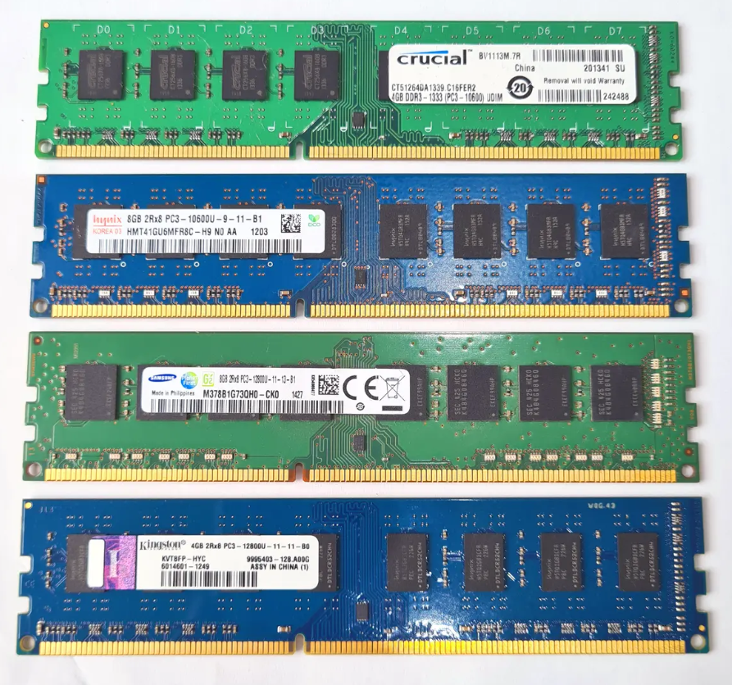

With the power switch and its neighboring components unwired from the motherboard, we can look into what many people consider to be one of the more important parts of a good PC. We have established various types of storage devices, but those use what is known as non-volatile storage/ memory. This simply means that anything stored on those devices will be retained even after they have lost power. But these types of storage devices alone can not make a functioning computer, which is where our RAM comes in. RAM is an essential component, and unlike regular storage devices, is considered to be volatile memory so any information on the RAM will be erased when it loses power. The reason why we need RAM is because it stores short-term information for anything on the computer that we need to access, provides instructions to the CPU on what to do and how to run programs, and appropriately to its name, it enables the CPU to have random access to any piece of data.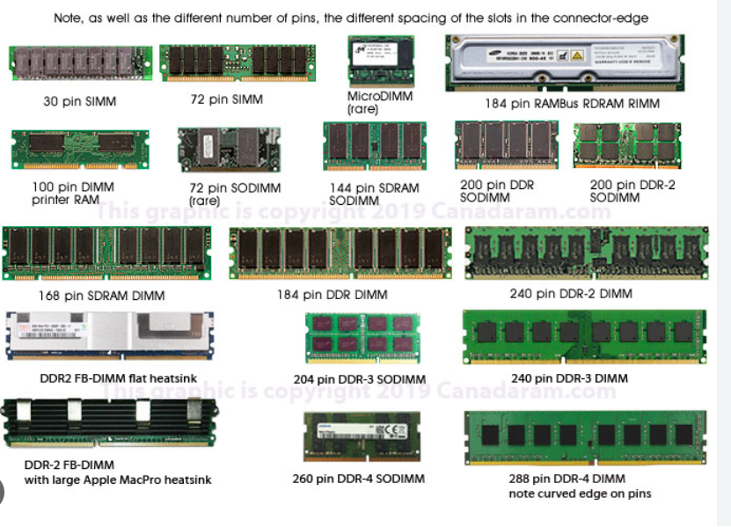

RAM comes in many different forms, with various data access speeds and short-term storage capacities. The three main types of RAM are as follows: DRAM, SRAM, and VRAM. VRAM is an acronym for Video Random Access Memory, suitably because it is specifically designed to be utilized by the GPU, for things like rendering videos or graphics in video games. We then have SRAM, which is an acronym for Static Random Access Memory and is simply a faster version of DRAM, but it’s more costly and draws more power from the PSU. It is referred to as static because it doesn’t need to be “refreshed” like DRAM does, which I will explain further shortly. DRAM, Dynamic Random Access Memory, the main and most common type of RAM, has many different variations that affect speed and power consumption. The issue with DRAM is that in order to retain the short term data stored on it, it needs to refresh itself constantly. To put it briefly, DRAM uses a transistor and capacitor to store every piece of data, and the charge slowly and constantly leaks out of the capacitor, so it needs to essentially refresh itself by rewriting all of the data stored on it in order for it to be maintained. This causes a bit of a delay in speeds, and since SRAM doesn’t need to refresh like this, it is faster. DRAM has many different options available, with the newer iterations (DDR5 is the newest) offering faster speeds and lower power consumption.

Essentially, the better RAM you have, the faster it can communicate with the CPU and thus faster you can perform tasks on your PC and access information. In addition, the larger storage capacity of RAM, the easier it will be for your PC to process data from multiple sources. It doesn’t end there. You can get even better performance by using Dual Channel or Multi Channel RAM. This quite literally means to use either 2 (Dual Channel) or 4 (Multi Channel) identical sticks of RAM in your configuration. Some modern motherboards are even supporting up to 8 RAM slots, which if used with the right RAM and CPU would provide incredible speeds.

To remove the RAM from our PC you simply need to lift up the little arm that secures the RAM into its slot and gently and carefully remove it. We should set aside our RAM sticks on the anti static mat as they can be susceptible to static.

**Step 10 - CPU** 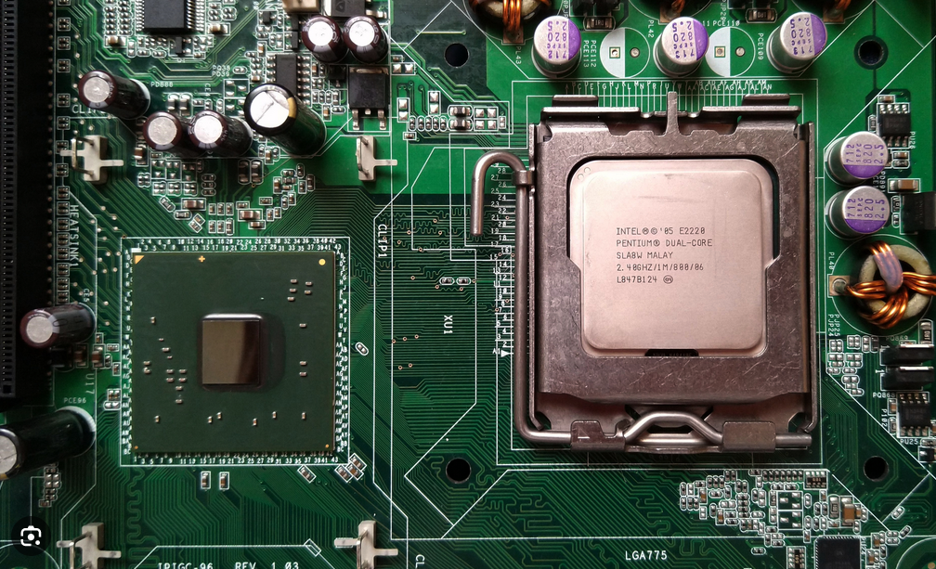

The brain of the computer, otherwise known as the CPU. It is what runs everything and makes everything you do on a PC have function behind it and similarly, your PC cannot function without it. It is the master of performing calculations and decoding instructions from the memory to facilitate everything that you see on your screen. Anything that anybody ever does on a PC runs through the CPU at some point in the cycle. In simple terms, the CPU works by receiving instructions in binary from RAM, processing what the instructions are asking it to do, and executing them.This is why it is so important in any kind of setup to have a good CPU. While some uses require more processing power, any kind of use case, be it gaming, serving files, programming, or even listening to music will be better off by having a high quality processor which will increase the speeds in which the processor can execute the code. The CPU is the most important part in this process and that is another reason that any good build should have a high quality CPU fan and heatsink, along with a proper application of thermal paste. Thermal paste is as described, a paste that helps with thermal conductivity. The thermal paste goes on top of what is called the “heat spreader”, which is covering the CPU, and between the heatsink. The heat spreader is a piece of metal which helps spread the heat from the CPU out more evenly. The paste then conducts the heat toward the heatsink which dissipates it with the help of the fan. As I mentioned earlier, an overheating CPU is a big problem so this must be done correctly. It will cost you a ton of performance and even make some tasks near impossible if something is done wrong. 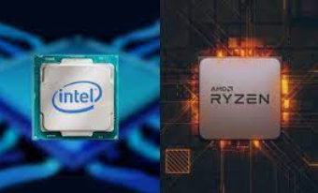

When designing a computer, the processor is often one of the first components picked because it helps determine what other components you will need to install with it for optimal performance. You firstly want to determine what manufacturer you prefer. AMD and Intel are by far the most popular choices, with Intel winning by a landslide. It is hard to find a pre-built system that does not have an Intel chip in it. This is largely because, while more expensive, Intel boasts much better performance and the majority of PC users will shell out a bit of extra money for that performance. Another reason is that the chip will determine other components of your PC as AMD and Intel processors use different chipsets and thus are only compatible with certain motherboards. It is also important that if you are designing a PC with a focus on performance and not on spending as little as possible, you ideally want to grab a processor from the current generation. I believe Intel is now in the 14th generation, and these processors at the higher tier are absolute beasts that can take on any challenge.

At this point in the disassembly process we will have already removed the case fan and possibly the heatsink (depending on the CPU fan config as talked about earlier). If the heatsink is still attached, we will remove it now by removing the bolts attached to the motherboard. We can then wipe the thermal paste off the heatsink and heat spreader and open the heat spreader. Here we will have access to the CPU itself. We can remove the CPU and put it somewhere safe. It is recommended to use an anti-static bag to put it in.

**Step 11 - Heatsink**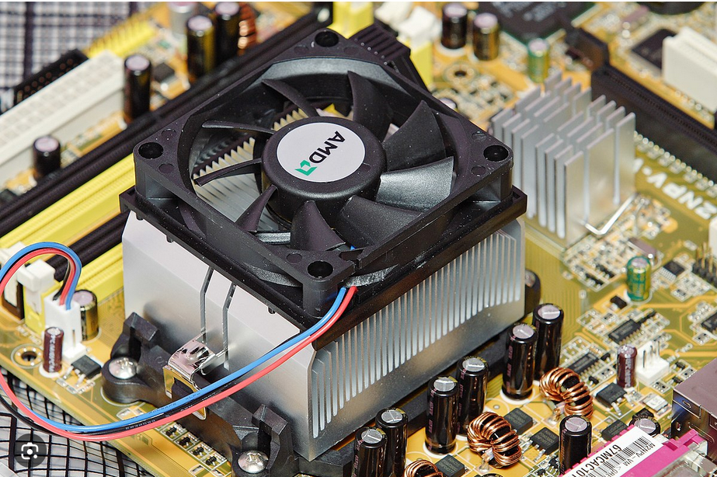

We’ve already removed the heatsink in earlier steps. With it removed, we can more closely look at its mechanism and how it works. Often made with either copper or aluminum, as these materials both have high thermal conductivity, it is a great method of removing heat from the CPU. It essentially absorbs all of the heat that is spread to it from the heat spreader and thermal paste.

The heatsink itself is designed with very thin and close together “fins” and “ridges”. They are placed in such a way to maximize surface area. The fins and ridges spread the heat out more evenly through the heatsink and air flowing around the heatsink helps to carry the heat away. This can further be enhanced by attaching a specific CPU fan to the heatsink to push even more air around it for even better heat dissipation.

This component is essential for a well maintained CPU. Modern high-end processors basically require a matching high-end CPU fan and heatsink for optimal cooling. Processors of the past sometimes had no fan and only a heatsink, but this is very rare these days. Luckily, good heatsinks are not too costly and easy to install for a great solution to keeping your PC cool.

**Step 12 - The Motherboard** 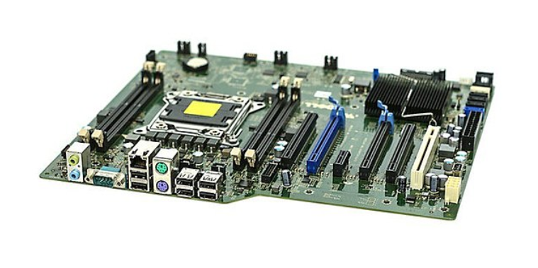

We’ve now landed on the final major component of our PC. The motherboard is what connects everything else together. Just like how we can’t build a PC without a CPU or RAM, we also could not build one without the motherboard. It holds your processor, RAM, expansion slots, and all of the interfaces and connections for all other hardware we need. It also connects to the power supply and provides that power to any other component that needs it (like the CPU!). The motherboard also contains the BIOS/ UEFI firmware which is essential to any computer. This controls all initiation of the operating system, controlling the on/ off power, and many other major settings that help our computers run smoothly. At its core, it is simply a circuit board but is much much more than that.

The motherboard also happens to be the piece that allows the other components to communicate with each other. Like when the RAM needs to talk to the CPU to provide its instructions, it must first talk to the motherboard which will then forward those instructions to the CPU. Every event that happens on a PC goes through the motherboard. You want to play a video game? The GPU needs to relay the images to the monitor but it must first go through the motherboard. You want to store something on an HDD? The CPU needs to send the compiled data to the motherboard which will direct it to the drive. These are just some examples to paint the picture that the motherboard is the mail pigeon for communicating everything that happens while using a computer. 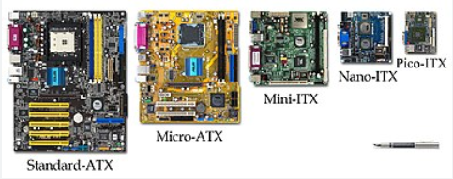

Motherboards come in different form factors, usually corresponding to the same sizes offered by PC cases. This is because just like how the case decides on what kind of components you can install, the motherboard does the same. A gaming PC with a 4080 for example will require a massive E-ATX case, and this is the same as we will then need an E-ATX motherboard to go with it. The size factor also often determines the inclusion or exclusion of other features, such as having 8 RAM slots on an ATX, but only 2 on Mini-ITX. It is also important that you buy a motherboard that is compatible with the chipset of your processor. For example, with Intel processors, you might find that they have chipsets such as “Skylake”, “Coffee Lake”, or “Rocket Lake”, and we must ensure that our motherboard can support the chipset of whatever process we are going to be using. Additionally, motherboards these days offer a lot of newer features that can be helpful, such as built-in Wifi, PCIe and m.2 slots, USB 3.0 and up, DDR4 support, overclocking, and RGB.

At this point we can remove the motherboard from the case. It will have many screws attached to it. Once we have unscrewed all of them, we will put it in a safe space, ideally an anti-static bag. With the motherboard out, we can proceed to remove any remaining cables or small parts in the PC. And with that, we have fully disassembled it.This would be a good time to deep clean the case, any fans, and other components. This process is time consuming and can be very frustrating at times, but it always feels rewarding in the end.

**Image Citations**

Step 1:

* Image: Turning off PC from start button
  + Source: Personal screenshot
* Image: Pressing PC top power switch
  + Source: Rick Broida
  + Link: Broida, Rick. "How to quickly shut down Windows 10." CNET.<https://www.cnet.com/tech/computing/how-to-quickly-shut-down-windows-10/>
* Image: PSU Power Switch
  + Source: Unknown
  + Link: Unknown (<https://www.akyga.com/news-list/68-how-to-choose-a-power-supply-for-my-desktop-pc.html>)

Step 2:

* Image: Antec Gaming PC case
  + Source: Antec
  + Link: Antec.<https://www.antec.com/product/case->
* Image: PC Case Sizes
  + Source: Chris (vile_is_dead)
  + Link: Chris (vile_is_dead).<https://www.xbitlabs.com/pc-case-sizes/>
* Image: Removing side panel
  + Source: Edward Shaw/E+/Getty Images
  + Link: Shaw, Edward. "How to open a desktop computer case." Lifewire.<https://www.lifewire.com/how-to-open-a-desktop-computer-case-2624589>

Step 3:

* Image: PSU unplugged
  + Source: eBay listing

Step 4:

* Image: Internal Optical Drive
  + Source: Wikipedia
  + Link: Wikipedia.<https://en.wikipedia.org/wiki/Optical_disc_drive>
* Image: How optical drive works
  + Source: Nathan Mahr
  + Link: Mahr, Nathan. "What is an optical drive: definition, types & function." Study.com.<https://study.com/academy/lesson/what-is-an-optical-drive-definition-types-function.html>
* Image: Slim external optical drive
  + Source: Unknown
  + Link: Unknown (<https://www.easeus.com/knowledge-center/optical-disc-drive.html>)

Step 5:

* Image: PC with case fans installed
  + Source: Katharine Castle
  + Link: Castle, Katharine. "How to build a PC: 2018." Rock Paper Shotgun.<https://www.rockpapershotgun.com/how-to-build-a-pc-2018-how-to-install-case-fans>
* Image: PC with lots of fans installed
  + Source: Decogear
  + Link: Decogear.<https://www.decogear.com/products/deco-gear-mid-tower-computer-case-with-3-sided-tinted-tempered-glass>

Step 6:

* Image: CPU fan with heatsink
  + Source: James Archer
  + Link: Archer, James. "How to install a CPU cooler." Rock Paper Shotgun.<https://www.rockpapershotgun.com/how-to-install-a-cpu-cooler>
* Image: CPU fan overheating graphic
  + Source: Bo Moore
  + Link: Moore, Bo. "CPU temperature overheat." PC Gamer.<https://www.pcgamer.com/cpu-temperature-overheat/>

Step 7:

* Image: HDD/SSD/m.2 size comparison
  + Source: Nzxt
  + Link: NZXT.<https://nzxt.com/news/what-s-the-difference-between-an-ssd-hard-drive>
* Image: SSD + HDD = SSHD
  + Source: Heloise Montini
  + Link: Montini, Heloise. "What is an SSHD: A guide to hybrid drives." SalvageData.<https://www.salvagedata.com/what-is-an-sshd-a-guide-to-hybrid-drives/>
* Image: Floppy Disks
  + Source: Wikipedia
  + Link: Wikipedia.<https://en.wikipedia.org/wiki/Floppy_disk>
* Image: NAS
  + Source: John Burek & John R. Delanet
  + Link: Burek, John & Delanet, John R. "The best NAS (Network Attached Storage) devices." PCMag.<https://www.pcmag.com/picks/the-best-nas-network-attached-storage-devices>

Step 8:

* Image: Front Panel Header
  + Source: chaitanya
  + Link: Chaitanya. "What is F-panel?" Electronics Hub.<https://www.electronicshub.org/what-is-f-panel/>
* Image: Momentary Switch
  + Source: Unknown
  + Link: Amazon.<https://www.amazon.ca/Button-Momentary-Switch-Shallow-Terminals/dp/B0050J1QYA>
* Image: Windows shutting down
  + Source: GRENTECH
  + Link: GRENTECH.<https://www.grenfellinternetcentre.com.au/how-to-fully-shutdown-windows-10/>

Step 9:

* Image: 4 RAM sticks
  + Source: eBay
  + Link: eBay.<https://www.ebay.ca/itm/163974246626>
* Image: Different types of RAM comparison
  + Source: Unknown (Author not listed)
  + Link: Computer-Answers.<https://computer-answers.ca/2012/computer-questions/glossary-of-memory-terms-and-definitions/>

Step 10:

* Image: CPU in motherboard
  + Source: Wikipedia
  + Link: Wikipedia.<https://en.wikipedia.org/wiki/Chipset>
* Image: AMD vs Intel CPU
  + Source: James Montantes
  + Link: Montantes, James. "Intel vs AMD CPUs: Which is better?" James Montantes.<https://james-montantes-exxact.medium.com/intel-vs-amd-cpus-which-is-better-645d29999fc>

Step 11:

* Image: Heatsink on Mobo
  + Source: Wikipedia
  + Link: Wikipedia.<https://en.wikipedia.org/wiki/Heat_sink>

Step 12:

* Image: Motherboard
  + Source: Wikipedia
  + Link: Wikipedia.<https://en.wikipedia.org/wiki/Motherboard>
* Image: Motherboard form factors
  + Source: Wikipedia
  + Link: Wikipedia.<https://en.wikipedia.org/wiki/Motherboard_form_factor>